From: https://grantpiperwriting.medium.com/the-forgotten-incident-that-helped-suck-the-us-into-wwi-cceac2520c2f
Author: Grant Piper
Date: Nov 8, 2022, 6 min read
Listen

The Forgotten Incident That Helped Suck The US Into WWI
  - Not the Zimmermann telegram or the Lusitania

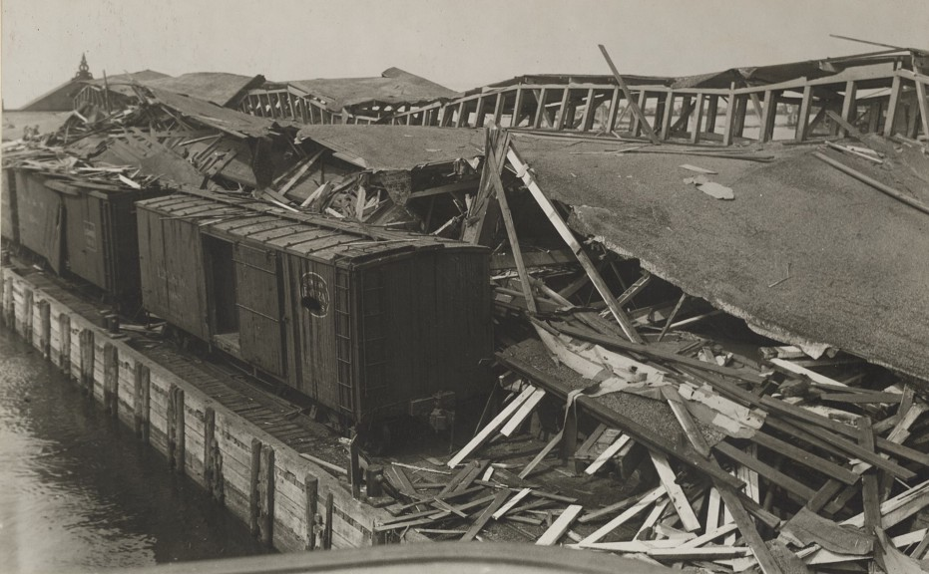
Black Tom explosion. (2022, November 3). In Wikipedia. https://en.wikipedia.org/wiki/Black_Tom_explosion
There are two big misconceptions surrounding the United States’ entry into the Great War. First, most people believe that the United States was truly neutral during the first few years of the war. The United States was neutral on paper, but in practice, they were funneling money and supplies to their allies in Europe. Second, most people assume that the Zimmermann telegram blunder or the sinking of American merchant shipping was to blame for the American people finally coming around to the idea of fighting a land war in Europe. While both of those things played a part, they don’t paint a complete picture.
But there is another incident that unfolded in July of 1916 that has largely been forgotten by the American public. On July 30th, 1916, one of the largest human-caused explosions in history rocked New York City. The blast was so powerful it damaged the Statue of Liberty. The explosion is known as the Black Tom explosion, and it was a pivotal part of the run-up to the American entry into World War I.

Black Tom Island
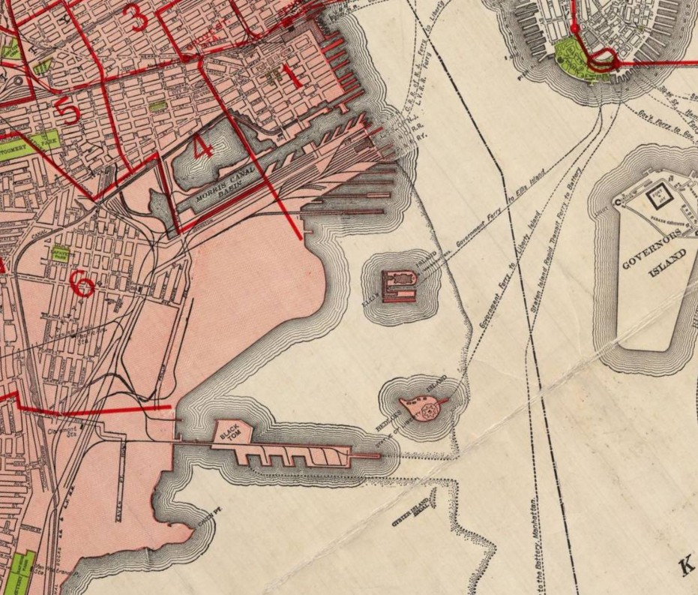
Black Tom explosion. (2022, November 3). In Wikipedia. https://en.wikipedia.org/wiki/Black_Tom_explosion
The explosion is named for a nasty island located in New York Harbor. The island was created as a landfill around a rock of the same name. Over decades, trash, waste, and debris from the nearby city were hauled out into the harbor via barge and dumped around Black Tom rock. Eventually, the landfill coalesced into an island that was eventually annexed and transformed into a warehouse district.
It was this small island located near Liberty Island that the United States began using as a covert ammunition dump. The island was out in the open and could easily hide barge and ship traffic in the busy harbor. The island was despised by locals and largely ignored. It was a perfect place to hide thousands of pounds of ammunition in plain view.
At the time of the explosion, thousands of pounds of munitions were being stored in preparation to be shipped to Russia. At the time, the Russian Empire was fighting for its survival on the eastern front, and the United States was desperately trying to funnel the required weapons to them to keep them in the fight against Germany.
This did not escape notice from local German agents who had been looking for the location of the United States weapons and ammunition. Despite being neutral, American weapons and ammunition kept appearing on battlefields in Europe. German agents were tasked with finding the source of the illicit ammunition and, if possible, destroying the source.

The Blast
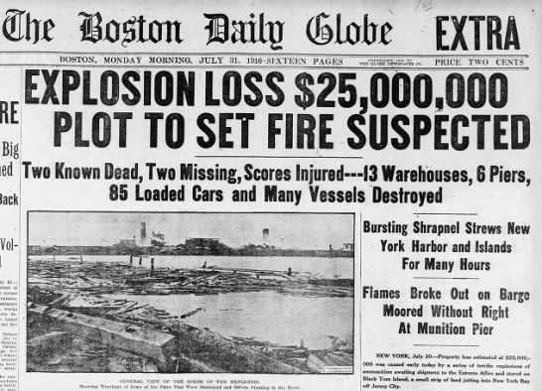
Black Tom explosion. (2022, November 3). In Wikipedia. https://en.wikipedia.org/wiki/Black_Tom_explosion
At 2:00 AM on July 30th, 1916, an explosion ripped through New York City. The explosion was so powerful that it sent debris flying over a mile away. Shards of metal and glass raked the nearby Statue of Liberty, causing over $100,000 in damage. Windows blew out across the city, and the blast left a massive smoldering crater on Black Tom Island. The crater measured 375 feet across.
At the time, it was one of the largest explosions in human history. Today, it still ranks as one of the most powerful non-nuclear explosions ever recorded.
Four people died, likely instantly. The fatalities were all people working on and around the island, including a barge captain that was supposed to transfer the munitions to a ship that was bound for Russia.
The explosion resulted in $20,000,000 in damage which is the equivalent of over $500,000,000 in damages today.
The explosion destroyed over two million pounds of ammunition and explosives being stored on the island.

Sabotage?
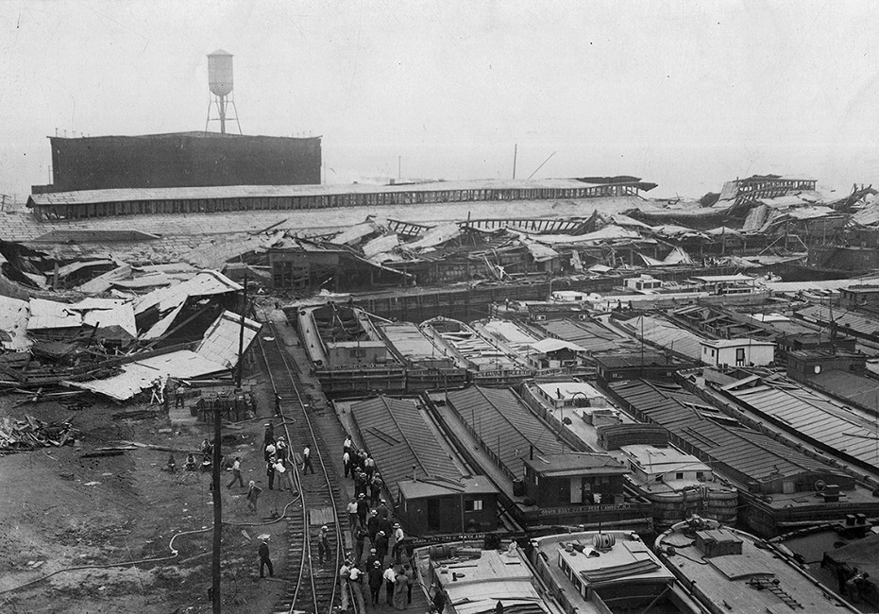
Black Tom explosion. (2022, November 3). In Wikipedia. https://en.wikipedia.org/wiki/Black_Tom_explosion
At first, the incident was reported as an accident. Munitions explosions were common, and seeing a storage depot go up in flames was not uncommon. However, after further investigation, it became more likely that the blast was the result of sabotage. Investigators turned up two German agents that were likely responsible for lighting a series of small fires along the docks near the warehouses that caused the massive explosion.
The Germans had found the source of American ammunition flowing to Europe and targeted it as instructed.
At the time, the official results of the investigation were pointless. People began telling each other that Germans had been responsible for the attack. Anti-German sentiment began to sweep the United States. That was a massive problem because Germans made up one of the largest ethnic groups in the country.
It didn’t matter if German agents were actually responsible for the explosion or if it was an accident. To the American public, Black Tom was detonated by German agents.
The fact that the explosion caused so much damage, including to the American symbol of liberty, in the heart of America’s most important city, rankled everyone. The torch of the Statue of Liberty closed indefinitely after the blast due to structural concerns.
The two agents suspected of committing the sabotage were never found or charged, though their identities were eventually uncovered. At the time, the United States did not have a homeland security department or dedicated intelligence service like the CIA. Sabotage remains the most likely cause of the Black Tom explosion, ahead of a simple accident.

A Shift In Public Sentiment
Up until this point, the American public was tacitly pro-German. Britain was still seen in an unfavorable light by many normal Americans. Many Americans had deep German ties and German heritage. The Black Tom explosion worked to shift American sentiment against Germany fully. The sinking of the Lusitania occurred over a year earlier. While that incident caused anger, it did not galvanize the American public to action.
The Black Tom explosion truly shifted American sentiment against Germany and German-Americans. Violence erupted across the country, and German businesses were vandalized. Anti-German propaganda began appearing in local newspapers.
All of this came to a head when the contents of the Zimmermann Telegram were made public the following year and pushed the United States into war.
The Black Tom explosion in conjunction with the sinking of American merchant ships at sea, made many Americans feel like they were already at war.

Legacy
The Black Tom explosion had many effects on the United States that are largely forgotten. The act of sabotage made the United States realize they needed a more robust intelligence service and national police force. The Black Tom explosion was instrumental in the creation and passing of the Espionage Act of 1917, which was used to harass German-Americans during the war.
The United States would finally enter World War I in 1917 after a culmination of various factors involving Germany.
Black Tom was also used as justification by FDR to inter thousands of Japanese-Americans in camps following the attack on Pearl Harbor in 1941. President Roosevelt allegedly said that he did not want “any more Black Toms” when he decided to sign the controversial order.
Black Tom was one of the most important incidents that finally pulled the United States into World War I, and yet it is largely forgotten. The damage was immense. The Statue of Liberty was wounded. Black Tom led to more robust intelligence services, controversial legislation, and the internment of Americans during World War II. Despite all of that, it is still an extremely obscure part of American history.

